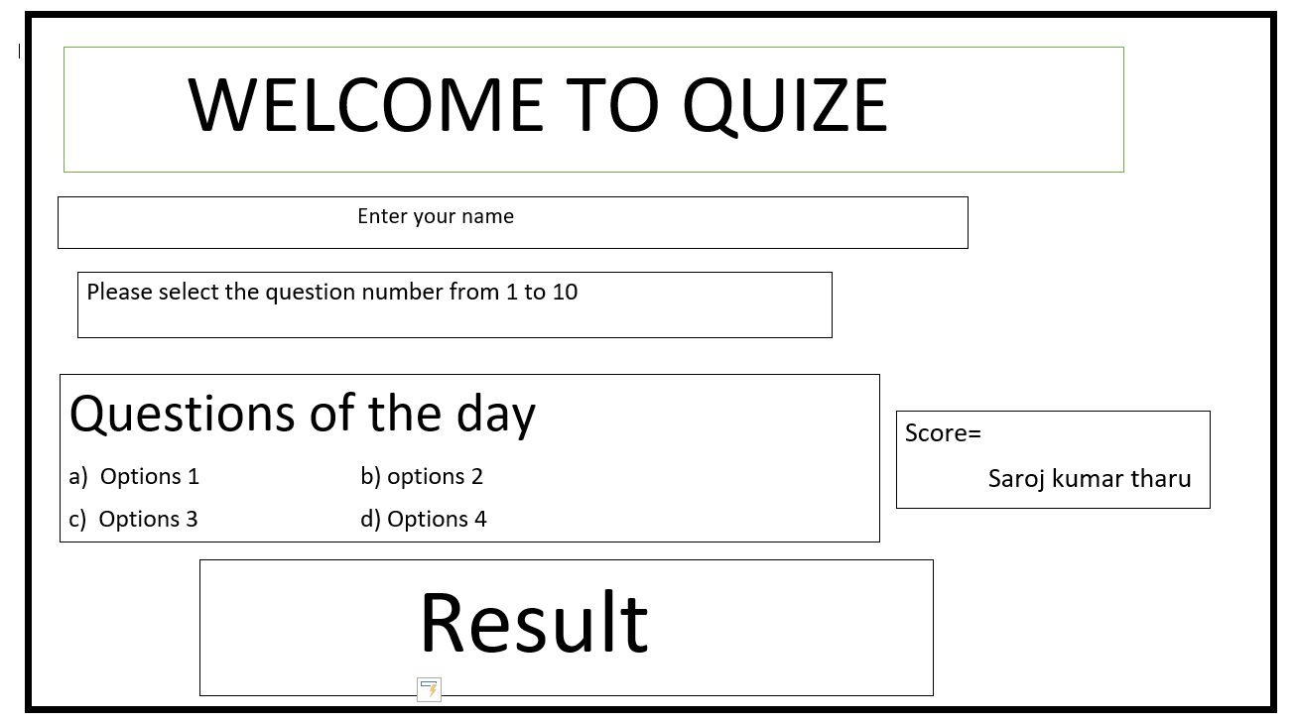

It will show the not only result but also the availbilty of the questions using a function

It will show the user name and Score of that user name which is current playing

It Will show the Question with options and select the options by using getch() function & should be remarks because it will show unavailable question if the same questions number is type twice

It will ask in after result but terminate if the gameover is become 1

It will run only once in the program after the start of the game and should be store in char variable.

Printf and goto statement